Date: | Time: | Location:
March 12th, 2026 | 0900-1100 | LifePlex (Plymouth, IN)

Topic: Discussion Leader:

Call to order: Lydia
- Officer roll call
- Moment of silence
- Acceptance of minutes
- New member introduction

Spotlight Presentations:
- Community Emergency Response Teams (CERT) – Gene Reed
- Board of Animal Health (BOAH) – District Update

District 2 Funds Review:
- Treasurer’s Report Mark
  - Checking: $54,925.18
  - Savings: $135,446.35
- Budget/Grant updates Mark
  - NSGP-NSS Grant (Submitted, awaiting to hear back)

District 2 Communications Drill Report: Lydia
- Mass notification drill via Preparis at 0930
  - February 2026: 37%
- Hospital/LHD tests on HOS/HOSPN at 1000, EMA tests on RM1/BMA-4 at 1015
- February 2026 Results
  - Hospitals: 100%
  - EMA: 100%
  - LHD:71.43
  - Dispatch: 100%
- Next: April 14, 2026

Old Business: Mark
- All updated policies are posted on the District 2 Website.
- Reminder to do HVA updates monthly on the first Friday at 0800.

New Business:
- Deliverable Review for BP2 Mark
- Training updates Jenn
- Policy Review/Updates Jenn
- MRSE Courtney/Mark

Good of the Order:
Member report out/discussion (any agency with information can speak)
- Public Health Any Local Public Health
- EMA Any EMA
- Hospital Any Hospital
- Outpatient (ASC/LTC/ESRD/HHC/Hospice, etc.) Any Outpatient
- Public Safety (EMS/Fire/Police/Dispatch) Any Public Safety
- IDOH Representatives Any
- IDHS Representatives Any
- INDOT/Toll Road Any
- National Weather Service NWS Representative
- Others

Upcoming Training:

Please ALSO see the training binder on the sign in table!

- ICS 400 -Early 2026- Elkhart County Health Department
  - Register on ACADIS and TEEX
- Readiness Training Identification and Preparedness Planning (MGT-418) – 4/16/26 – 4/16/26 – Elkhart County Health Department
  - Register on ACADIS and TEEX
- Flooding Hazards – Science and Preparedness (AWR-362) – 6/19/26 – Elkhart County Health Department
  - Register on ACADIS and NDPTC
- Tornado Awareness (AWR-326) – 8/21/26 – Elkhart County Health Department
  - Register on ACADIS and NDPTC

Adjournment/Next Meeting:
- April 9th, 2026 at 9:00 AM at LifePlex

District 2 HCC Executive Board
 |  | 
Lydia Spencer, DHSc  HCC/501c3 Chairperson/LHD Liaison/PHEPCA Rep  Phone: (574) 523 – 2126  Email: lspencer@elkhartcounty.org | Emily Neufeld  HCC/501c3 1st Vice Chair / Hospital  Phone: (574) 533 – 1234  Email: emily.neufeld@oaklawn.org | Jason Bailey, MD  HCC/501c3 2nd Vice Chair / Hospital  Phone: (574) 849 – 4555  Email: jbailey@beaconhealthsystem.org
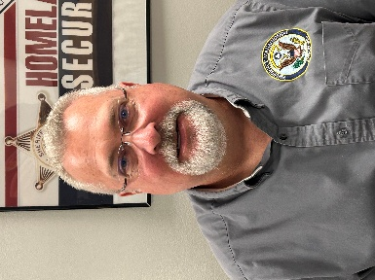 | 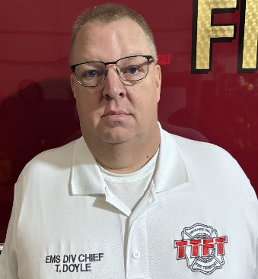 | 
Kip Shuter, MBA  EMA Representative  Phone: (574) 371 – 2602  Email: kshuter@kosciusko.in.gov | Tony Doyle, CCEMTP  EMS Representative  Phone: (574) 551 – 8872  Email: tdoyle@ttftfire.com | Angela Hostetler  Secretary/Hospital  Phone: (260) 248 – 9327  Email: angela.hostetler@parkview.com
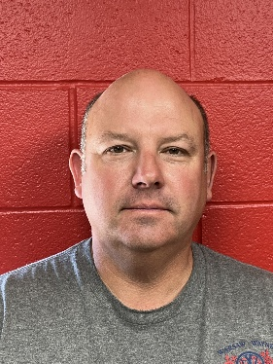 | 
Aaron Bolinger  Member At Large  Phone: (260) 705 – 0616  Email: abolinger@warsaw.in.gov | Kim Brown, RN, BSN, CASC, CAIP  Member At Large  Phone: (574) 202 – 5304  Email: kbrown71505@aol.com

District 2 Consultants
 | 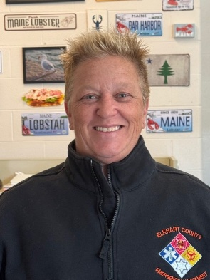
Mark Philson, MPA, CHEP, NREMT  D2 Readiness and Response Coordinator  Phone: (574) 855 – 7582  Email: d2admin@indianadistrict2.com | Jenn Tobey, CEM, PEM  D2 Planning Coordinator  Phone: (574) 238 – 0144  Email: jtobey@elkhartcounty.com
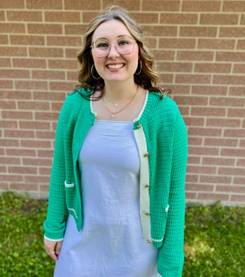 | 
Courtney Mathews  D2 Training and Exercise Coordinator  Phone: 269 – 919 – 2150  Email: TEC@indianadistrict2.com | Danielle Briney, MSN, RN  D2 Clinical Advisor  Phone: (574) 807 – 8628  Email: dbriney@apsurgery.com

District 2 EMAs
Name: | County: | Email: | Phone:
Dawn Sewell | Fulton | ema@co.fulton.in.us
Jennifer Tobey | Elkhart | jtobey@elkhartcounty.com | 574-891-2238
Kip Shuter | Kosciusko | kshuter@kosciusko.in.gov | 574-371-2602
Jack Garner | Marshall | ema@co.marshall.in.us | 574-936-3740
Richel Fox | Pulaski | pulaskiema@pulaskicounty.in.gov
Victoria Chessor | Starke | v.chessor@starke.in.gov | 574-806-1838
Al (Buddy) Kirsits | St. Joseph | Akirsits@sjcindiana.com | 574-360-9345

District 2 Coordinators
Name: | Title: | Email: | Phone:
Travis Clary | D1 & D2 EMS District Manager | tclary@dhs.in.gov | 317-746-0226
Garrett Anderson | Response Readiness Supervisor | ganderson2@health.in.gov | 317-233-1382
Rick Brown
Dustin Drake | NE IDHS Liaison | DuDrake@dhs.IN.gov | 317-800-8150
Amy Bluhm | NW IDHS Liaison | ABluhm@dhs.in.gov | 317-771-5952

